**A Report**

**on**

**Audio Watermarking**

**Submitted for partial fulfilment of the requirements for the**

**Mini project Laboratory**

**of**

**BACHELOR OF ENGINEERING** **IN** **COMPUTER SCIENCE AND ENGINEERING**

**by**

SYED FAIZAN AHMED  **(1604-19-733-013)**

MOHD. HUSAMUDDIN ARIF **(1604-19-733-020)**

**Under the guidance of**

**Mr. Md. Zainuddin Naveed**

**Assistant Professor**

**Department of Computer Science and Engineering**

**MJCET, Hyderabad.**



**Department of Computer Science and Engineering**

**Muffakham Jah College of Engineering and Technology**

**Hyderabad-500034**

**TABLE OF CONTENTS**

|  |  |
| --- | --- |
| **Description** | **Page No** |
| Certificate | 3 |
| Declaration | 4 |
| Acknowledgement | 5 |
| Abstract | 6 |
| Chapter 1  Introduction  1.1 Objective  1.2 Methodologies  Chapter 2  Literature Survey  2.1 Existing System  2.2 Proposed System  Chapter 3  Software Used  Chapter 4  Requirements  4.1 Running the WebApp on local Server  4.2 Running the Deployed WebApp  Chapter 5  Implementation  5.1 WebApp  Chapter 6  Limitations, Future Enhancements & Conclusion  6.1 Limitations  6.4 Future Enhancements and Conclusion | 7  8  9  10  11-13  14 |
| References | 15 |

**CERTIFICATE**

This is to certify that the project work entitled **“Audio Watermarking”** is a bonafide work carried out by

**SYED FAIZAN AHMED (1604-19-733-013)**

**MOHD. HUSAMUDDIN ARIF (1604-19-733-020)**

in partial fulfillment of the requirement for the Mini project laboratory of

**BACHELOR OF ENGINEERING IN COMPUTER SCIENCE AND ENGINEERING** by the **OSMANIA UNIVERSITY**, Hyderabad

under our guidance and supervision. The results embodied in this report have not been submitted to any other university or institute for the award of any degree or diploma.

Course coordinator

**Mr. Md. Zainuddin Naveed**

Assistant Professor

Department of CSE

MJCET, Hyderabad.

**DECLARATION**

This is to certify that the work reported in the mini project entitled **“Audio Watermarking’’** is a record of work done by us in Department of Computer Science of Engineering, Muffakham Jah College of Engineering and Technology, Osmania University. The report is based on the project work done entirely by us and not copied from any other source.

**SYED FAIZAN AHMED**

**MOHD HUSAMUDDIN ARIF**

**ACKNOWLEDGEMENTS**

We would like to express our sincere gratitude and indebtedness to our project course coordinator **Mr. Md. Zainuddin Naveed** for his valuable suggestions and interest throughout the course of this project.

We are also thankful to head of the department **Dr.A.A. Moiz Qyser** for providing excellent infrastructure and a nice atmosphere for completing this project successfully.

We convey our heartfelt thanks to the lab staff for allowing us to use the required equipment whenever needed.

Finally, we would like to take this opportunity to thank our families for their support through the work. We sincerely acknowledge and thank all those who gave directly or indirectly their support in completion of this work.

**SYED FAIZAN AHMED**

**MOHD HUSAMUDDIN ARIF**

**ABSTRACT**

**Objective:**

As we have seen that due to drastic increase in number of COVID patients across the globe, hospitals have now allotted a separate ward to treat COVID patients. But they don’t have a management system which can separately store details of General and COVID patients. To overcome this issue, we have proposed a short and simple Hospital Management System in which the Admin and Wards of the hospital can access to store details into the system of both COVID and general admitted patients separately and track the status of patients.

**Software requirements:**

1.Code editor- Visual Studio Code

2.Django - a python-based web- framework

3. A suitable web browser (Preferably Google Chrome)

**Conclusion:**

By this project, we can help the hospitals to manage COVID and general patients separately, hence it makes convenient for the management to track the patients' details effectively.

**CHAPTER 1**

**INTRODUCTION**

This chapter gives an outline about the aim, objectives, background and operation environment of the system.

* 1. **OBJECTIVES**

The project aims and objectives that will be achieved after completion of this project are discussed in this subchapter. The aims and objectives are as follows:

* Online Enrollment of patient details.
* Request information of number of patients in each ward undergoing treatment
* A separate login credential for each ward of the hospital
* Admin dashboard where we can view, edit, update, create or delete patient details
* Ward login dashboard where they can view patients’ details of their ward particularly
* Reset password feature via Email for all registered users of the hospital

**1.2 METHODOLOGIES**

There are considerable methodologies and theories in which to conduct a research for this topic.

The use of User Satisfaction Questionnaire as a method for the research is quantifiable and effective to come up with valid and reliable results. The purpose is to establish a baseline for user satisfaction. Selection of hospital staff will be identifying by experience, ward, frequency of use and other demographic elements. Moreover, the contextual inquiry is an approach to study technique combining observation and interview methods to gain an interpretation of work practice.

**CHAPTER 2**

**LITERATURE SURVEY**

**3.2 EXISTING VS PROPOSED SYSTEM**

1. Existing system does not have any facility of separate ward login whereas proposed system will have a facility of separate ward login.
2. Existing system does not have a facility of online enrollment of patient details whereas proposed system has a facility of online patient registration by the staff login.
3. Existing system does not have any facility of create, update or delete the entered or saved patients’ data whereas the proposed system has that functionality.
4. Existing system does not have any option of resetting password with a secure verification such as sending reset link via mail but the proposed system has this facility.
5. Existing system does not have any facility to segregate patients into COVID and General wards and manage the data separately whereas the proposed system is facilitated with this feature by adding separate ward in the application.

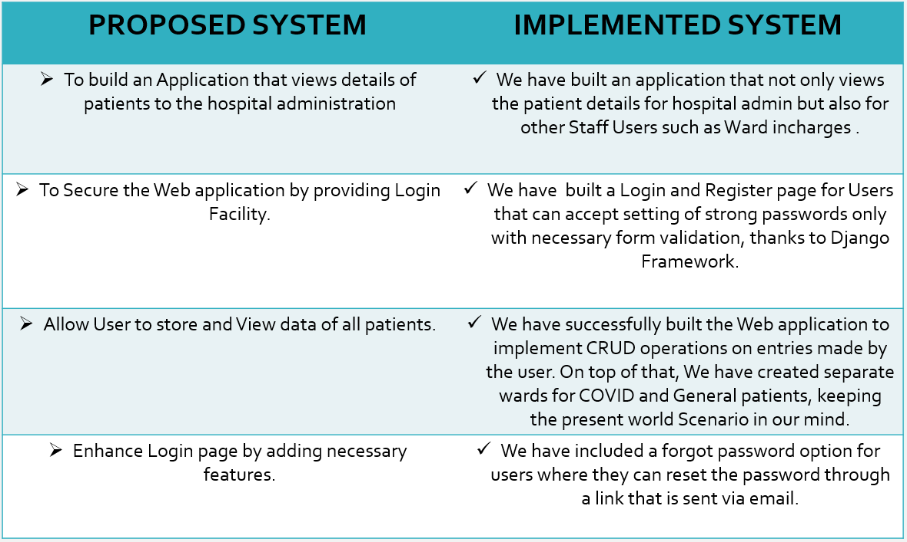

**CHAPTER 3**

**SOFTWARE USED**

* **PYTHON-** Python is an [interpreted](https://en.wikipedia.org/wiki/Interpreted_language), [high-level](https://en.wikipedia.org/wiki/High-level_programming_language) and [general-purpose programming language](https://en.wikipedia.org/wiki/General-purpose_programming_language).  It was created by Guido van Rossum, and released in 1991. Python's design philosophy emphasizes [code readability](https://en.wikipedia.org/wiki/Code_readability) with its notable use of [significant indentation](https://en.wikipedia.org/wiki/Off-side_rule). Its [language constructs](https://en.wikipedia.org/wiki/Language_construct) and [object-oriented](https://en.wikipedia.org/wiki/Object-oriented_programming) approach aim to help [programmers](https://en.wikipedia.org/wiki/Programmers) write clear, logical code for small and large-scale projects. Python can be used on a server to create web applications.
* **DJANGO-** Django is a high-level Python Web framework that encourages rapid development and clean, pragmatic design. Built by experienced developers, it takes care of much of the hassle of Web development, so you can focus on writing your app without needing to reinvent the wheel. It's free and open source. Django is a collection of Python libs allowing you to quickly and efficiently create a quality Web application, and is suitable for both frontend and backend.
* **SQLite-** SQLite is a C-language library that implements a [small](https://www.sqlite.org/footprint.html), [fast](https://www.sqlite.org/fasterthanfs.html), [self-contained](https://www.sqlite.org/selfcontained.html), [high-reliability](https://www.sqlite.org/hirely.html), [full-featured](https://www.sqlite.org/fullsql.html), SQL database engine. SQLite is the [most used](https://www.sqlite.org/mostdeployed.html) database engine in the world. SQLite is an embedded SQL database engine. SQLite database files are a [recommended storage format](https://www.sqlite.org/locrsf.html) by the US Library of Congress.
* **VISUAL STUDIO CODE-** Visual Studio Code is a lightweight but powerful source code editor which runs on your desktop and is available for Windows, macOS and Linux. Features include support for [debugging](https://en.wikipedia.org/wiki/Debugging), [syntax highlighting](https://en.wikipedia.org/wiki/Syntax_highlighting), [intelligent code completion](https://en.wikipedia.org/wiki/Intelligent_code_completion), [snippets](https://en.wikipedia.org/wiki/Snippet_(programming)), [code refactoring](https://en.wikipedia.org/wiki/Code_refactoring), and embedded [Git](https://en.wikipedia.org/wiki/Git). Users can change the [theme](https://en.wikipedia.org/wiki/Theme_(computing)), [keyboard shortcuts](https://en.wikipedia.org/wiki/Keyboard_shortcut), preferences, and install [extensions](https://en.wikipedia.org/wiki/Plug-in_(computing)) that add additional functionality.

**CHAPTER – 4**

**REQUIREMENTS**

**4.1 RUNNING THE WEB APP ON LOCAL SERVER**

The requirements to run the Web App successfully on local server are-

* Any code editor (VS Code preferred)
* Django installed in a virtual environment
* Some other requirements are: Django-filter (version 2.4.0 is used) and Pillow (version 8.1.0)

**4.2 RUNNING THE DEPLOYED WEBSITE**

A good internet connection and a browser (chrome or any other) is required to view the website and use it. It works best when viewed on Laptop and PC.

**eld Data type Default Key Extra**

**HOSPITAL ADMIN MODULE:**

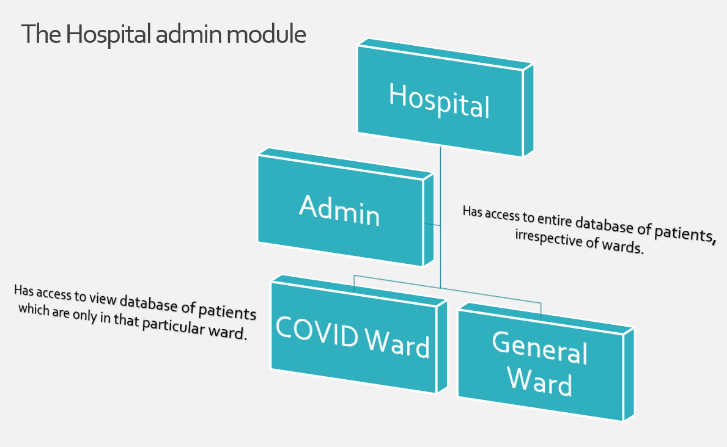

**CHAPTER 5**

**IMPLEMENTATION**

**5.1 SCREENSHOT FOR HOMEPAGE**

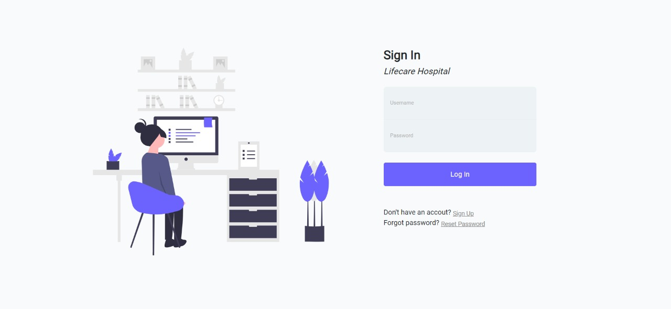

**5.2 SCREENSHOT FOR ACCOUNT REGISTER**

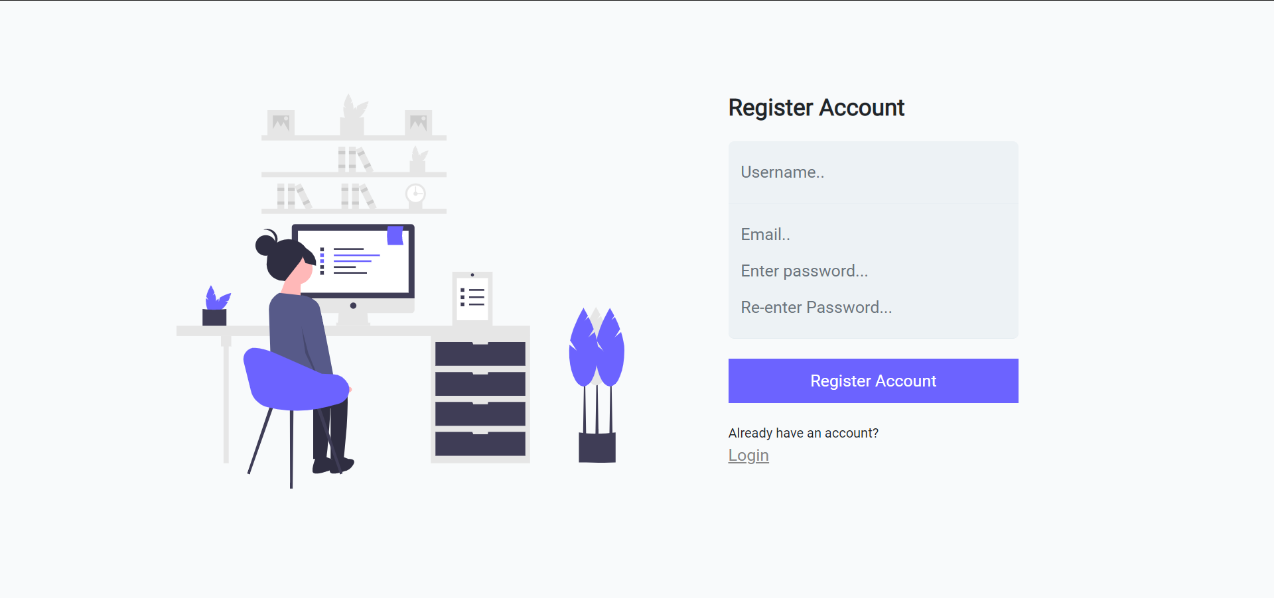

**5.2 SCREENSHOT FOR DASHBOARD**

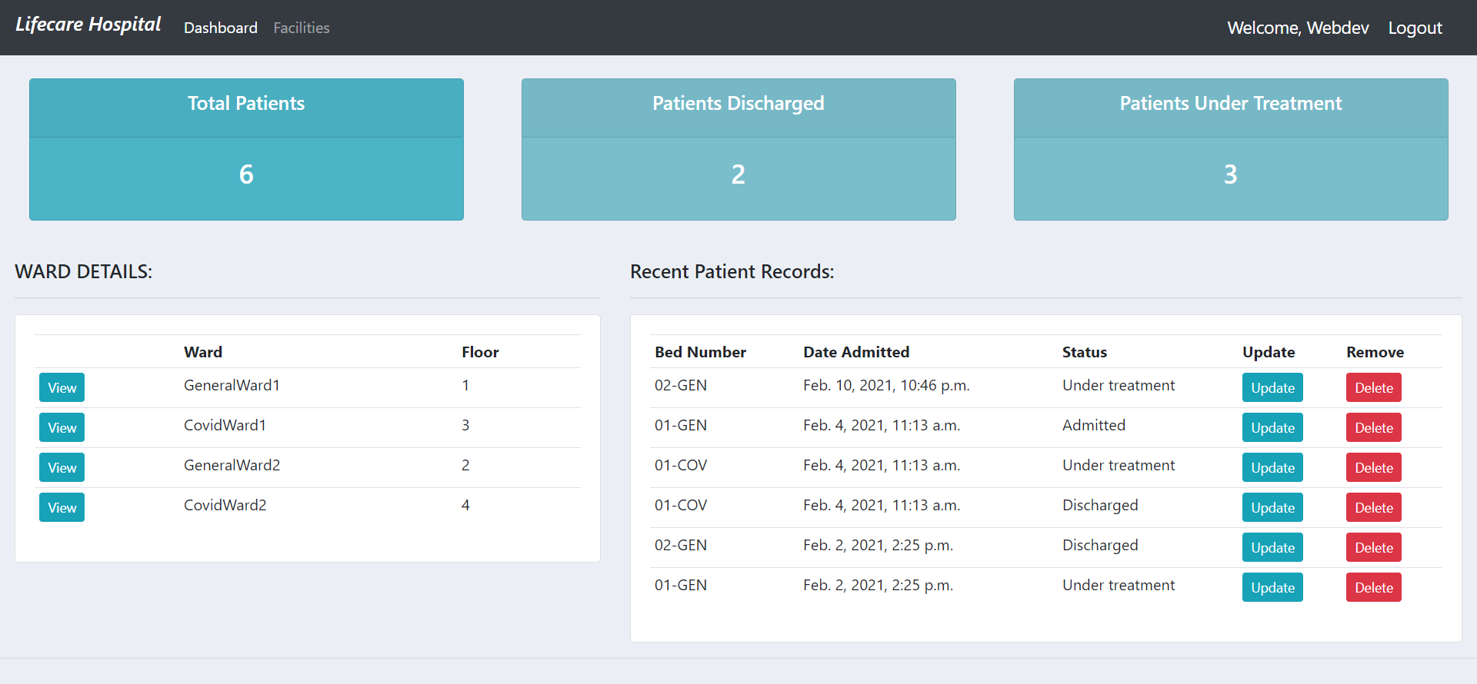

**5.3 SCREENSHOT FOR WARD PAGE**

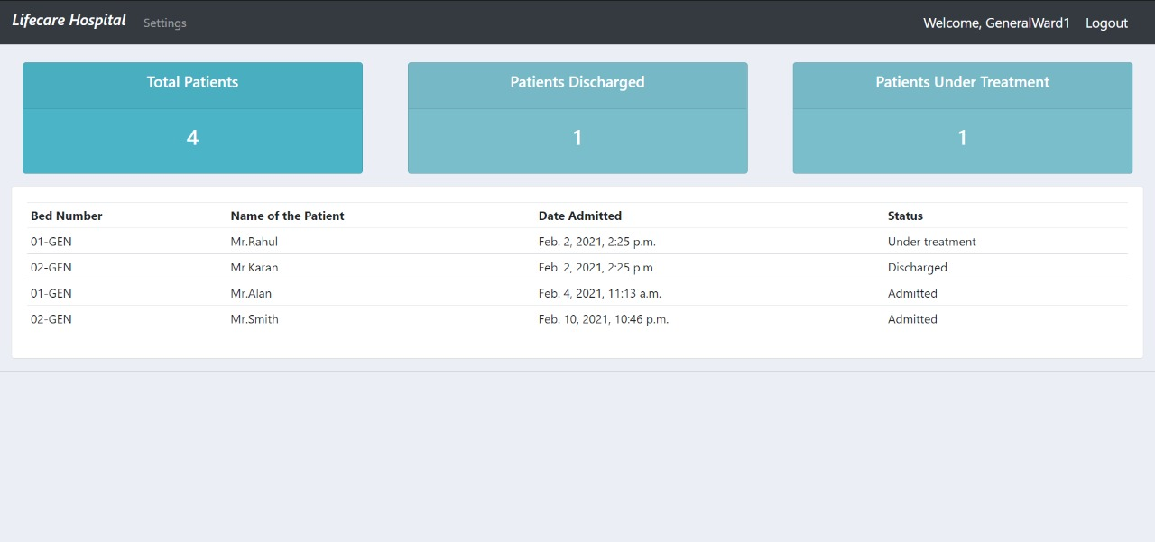

**5.4 SCREENSHOT FOR DETAILS OF PATIENT AND SEARCH FUNCTIONLITY**

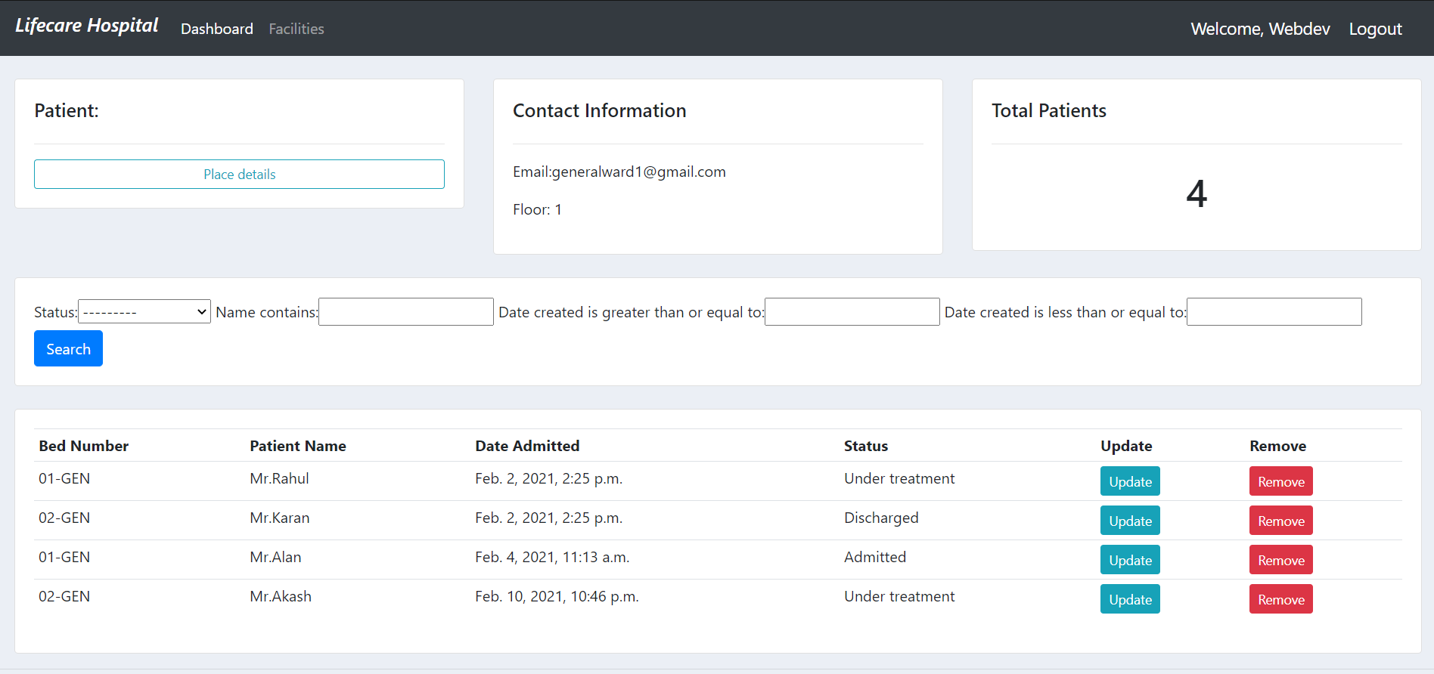

**CHAPTER 6**

**Limitations, Future Enhancements & Conclusion**

**6.1 LIMITATIONS**

Without computers, as some hospitals are, all of them are dependent on paper work. When compared to computerized systems, data backup and data retrieval systems are inefficient and labor intensive.   
 Users of a paper-based system become almost wholly reliant on the hospital staff, for all levels of service, whether they are enquiries about current patients, ward-wise stats, etc. There is additionally no real involvement of a user in the entire process. Researching which patient is in which ward by hospital staff becomes very difficult, and again, labor intensive.

**6.2 CONCLUSIONS AND FUTURE SCOPE**

This application provides a web application of hospital management system which will benefit the staff of the hospital.It makes entire process online where hospital staff can search patients, staff can view, update create or delete a patient entry. Since the project has a separate admin portal for owner of the Web application, hospital owners can access to all details of the hospital with respect to each ward. Each ward has its own login credentials to store and view the details of patients of its ward. The billing staff can have a record of how many patients are undergoing treatment etc. from this application.

There is a future scope of this facility that many more features can enhance its functionality such as:

* Adding data of hospital staff along with their primary details and creating separate login for them.
* Creating separate portal for patients that can be monitored by the ward and hospital management
* Adding billing details of each patient under his details
* Displaying which doctor is appointed to which patient.
* Billing details of each patient.
* What kind of treatment/tests/operation the patient has underwent

**REFERENCES**

* <https://docs.djangoproject.com/en/3.1/>
* <https://www.youtube.com/playlist?list=PLsyeobzWxl7r2ukVgTqIQcl-1T0C2mzau>
* <https://www.w3schools.com/html/>
* <https://www.w3schools.com/css/default.asp>
* Django 3 By Example by Antonio Mele